Virtual Box Setup and Configuration

You can download virtual box by going to the following link. You will need to select Ubuntu 18.04 Specific install. Clicking the install link will download a Debian package file. Launch the .deb file to install the virtual box package.

Virtualbox.org/wiki/Linux_Downloads

You should be able to launch the .Deb file in your downloads and get the following page to install.

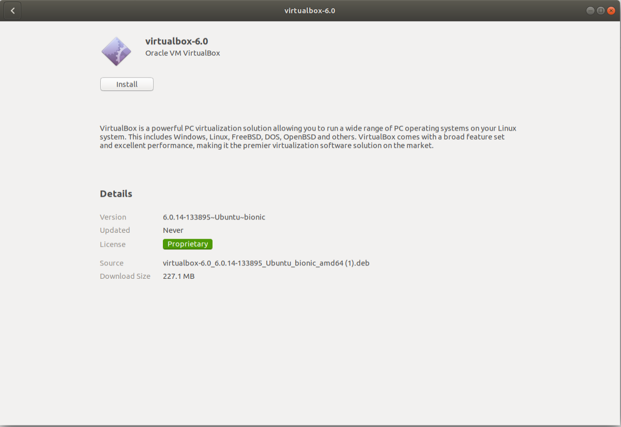

After running VirtualBox you should have this screen. Click New to create a new virtual machine.

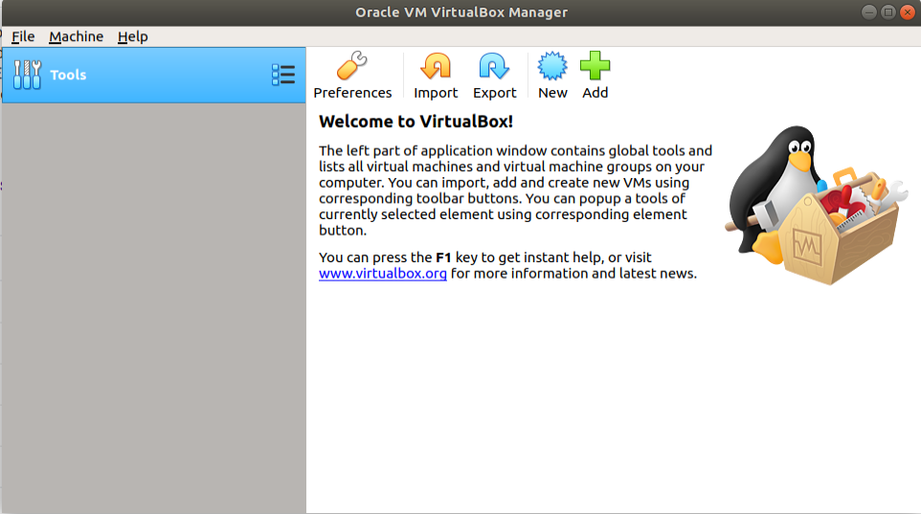

Select the amount of RAM you’d like your virtual machine to have. OpenVAS recommends at least 8 gb of ram.

Create A virtual Hard disk, selecting VDI (Virtualbox Disk Image)

Either Dynamically Allocated or Fixed Size would work. If you select Fixed Size give the Virtual Machine around 30-50gb Minimum.

After selecting the file location of the VM and the size you’ll be able to create the Virtual Machine

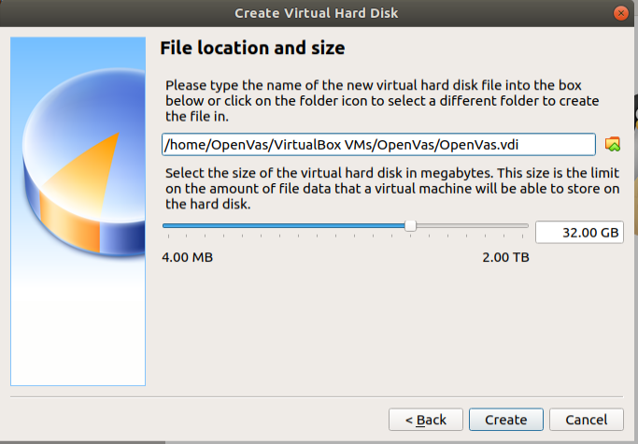

After clicking create you should have a virtual machine ready to install ubuntu 18.04 on.